**Project Planning 2**

**Demo**  
  
What you have done on the Project since last time?

-We have searched for the datasets regarding to our project title.

-We have also cleaned the datasets by sorting it into Asians only. Removed unwanted data which is data that aren’t related to Asians.

-We have started to create charts such as heat map for our data visualization purposes.

What you plan to complete before the next stand-up?

-Search for more datasets regarding our project and create different charts such as bar graph or pie chart before the next project planning.

What obstacles you are facing in completing your deliverables?

-There were small obstacles we were facing, such as searching for datasets but we overcome the issue once we found our dataset.

**Submission**

***\*paste in text box on canvas***

List of what you have done since last standup.

-Search for datasets.

-Clean the datasets.

-Remove unwanted data in the datasets

-Sort the datasets.

-Creating our 1st chart which is a heat map by using JavaScript.

**Image of our Dataset 1.**

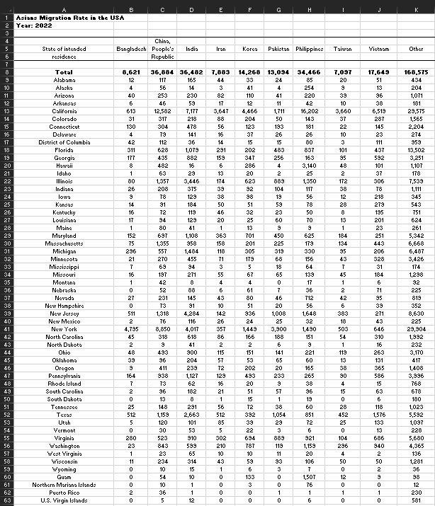

**Image of our 1st Chart (Heat Map)**

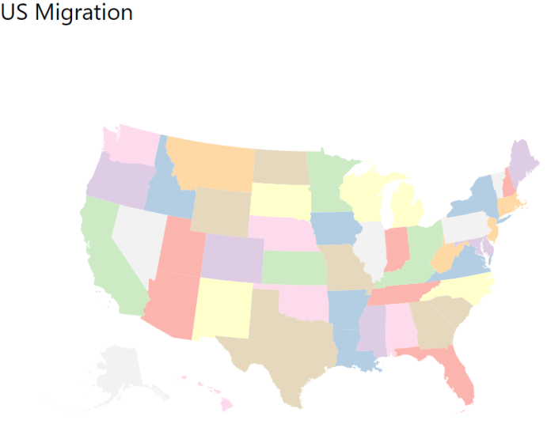

**Image of the coding for our Heat Map**

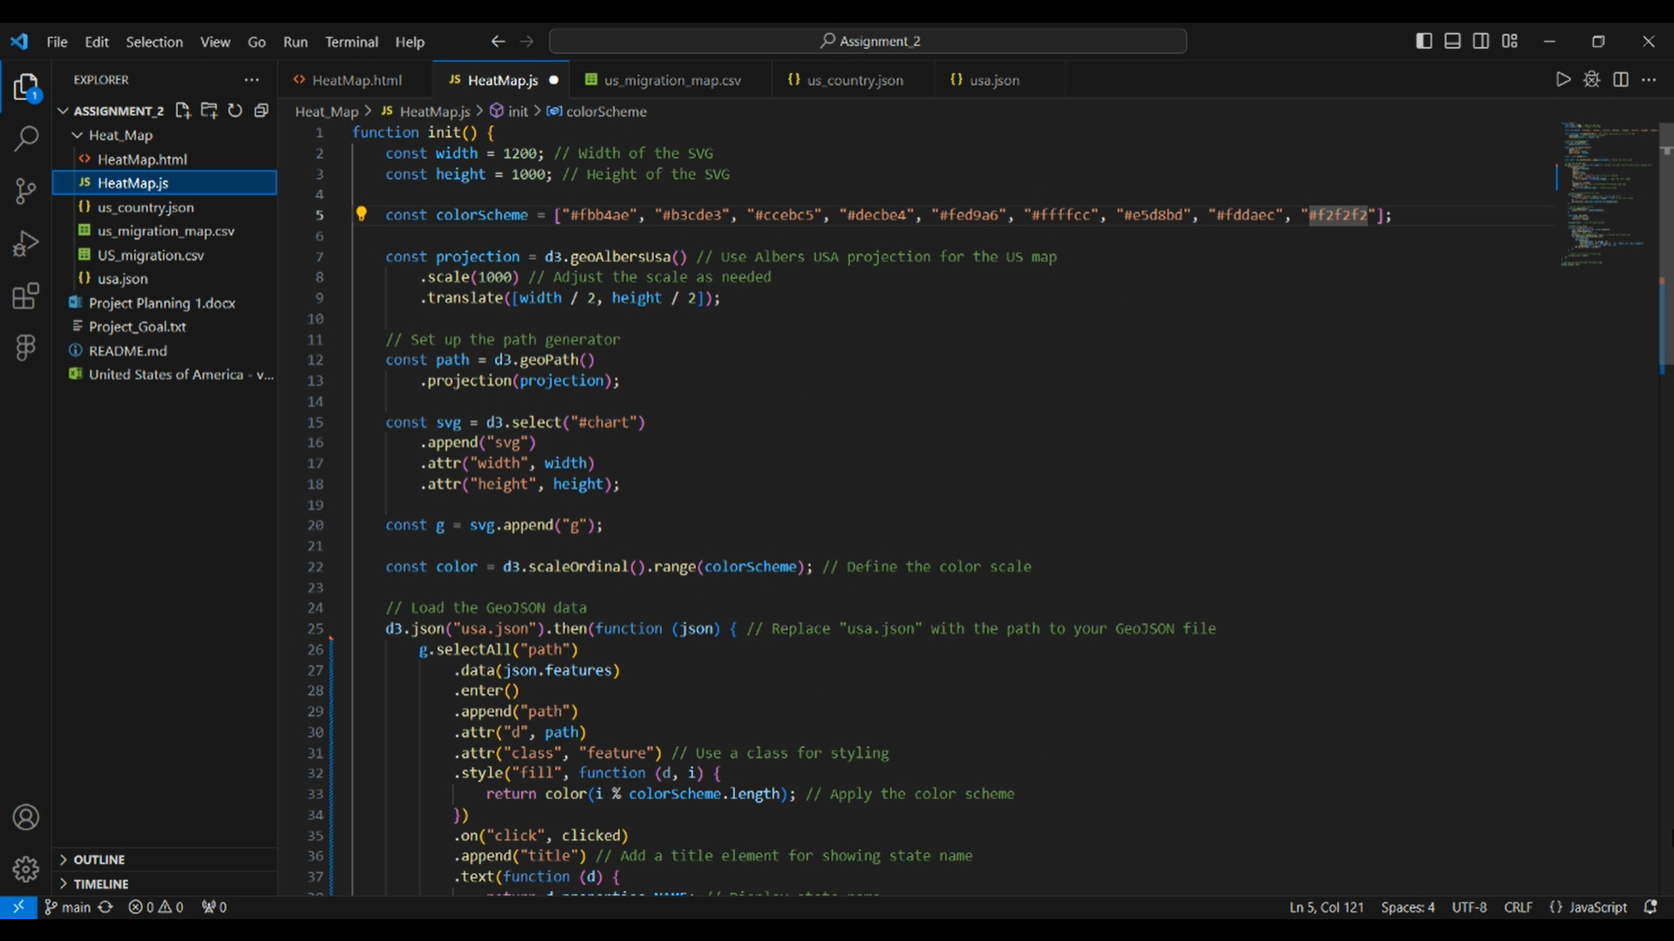

Estimate of your contribution (in hours and % of work completed by team so far) to:

|  |  |  |
| --- | --- | --- |
|  | Lam Mun Swee | Wan Zhen Yao |
| Finding and working with the data set | Time taken: 200 hours  Percentage of work completed: 90% | Time taken: 3 hours  Percentage of work completed: 10% |
| Designing the visualisation | Time taken: 1 hour  Percentage of work completed: 30% | Time taken: 5 hours  Percentage of work completed: 70% |
| Contributing to writing up the Process Book | Time taken: 0 hours *Have not started on the final report yet.  Percentage of work completed: 0% | Time taken: 0 hours *Have not started on the final report yet.  Percentage of work completed: 0% |
| Writing/researching code | Time taken: 2 hours *Mostly researching   Percentage of work completed: 20% | Time taken: 3 hours *Mostly writing  Percentage of work completed: 80% |

Summary of to-dos before next standup.

-Continue to search for more datasets / use our current dataset and modify the values in the datasets to use in different charts.

-Organize the datasets by filtering and sorting the data as well as removing unwanted data in the datasets.

-Create different charts such as bar graph, pie chart and etc.

Any issues with teamwork.

No.